Lucy Watling

**The Erster Deutscher Herbstsalon Word Count:** 498

The *Erster Deutscher Herbstsalon* (First German Autumn Salon) was one of the most important large-scale international exhibitions of Modern art to be shown in Germany before the First World War. Staged in derelict rooms on Berlin’s Potsdamer Strasse between 20 September and 1 December 1913, the exhibition included over 360 works by some 90 artists. It was organised by the Berlin writer and critic Herwarth Walden (1878-1941) under the banner of his Der SturmGallery, working in collaboration with a group of Expressionist artists including Wassily Kandinsky, August Macke and Franz Marc, known by their collective name *Der* *Blaue Reiter*. The exhibition’s title was taken from the *Salon d’automne*, an annual display of avant-garde art which had taken place in Paris since 1903. Many in Germany – in particular the *Blaue Reiter* artists – increasingly felt that the development of modern art was no longer being adequately represented by these Paris shows. So, as Walden wrote in his foreword to the catalogue, the *Erster Deutscher Herbstsalon* sought to, ‘give an overview of the new movements in the pictorial arts of all countries’, that would, ‘at the same time…broaden our view of the contemporary’.

Walden founded the journal *Der Sturm* in Berlin in 1910 as a showcase for the expressionist movement in art and literature; from 1912, he staged exhibitions under the same name. Discussions for the *Herbstsalon* began in spring 1913 when Walden met with Kandinsky, Macke and Marc in Bavaria. With financial support secured from Berlin patron Bernhard Koehler, the uncle of Macke’s wife, the work of gathering exhibits began. In the final hang, decided by Walden, Marc, Macke and Koehler, the *Blauer Reiter* artistswere well represented, but the show also included artists from further afield: Italian futurists, Russians Natalia Goncharova and Mikhail Larionov, the Dutch artist Jacoba van Heemskerck and the American Lyonel Feininger. Robert and Sonia Delaunay, whom Walden had visited in Paris to obtain works, were each represented by over twenty pieces. The Delaunays’ collection also contributed to the 22 exhibits by French artist Henri Rousseau. In the *Blaue Reiter Almanach*, published by the group in 1912, Kandinsky had praised Rousseau as representative of a primitivist realism which could, he argued, provide an alternative to abstraction for the progression of modern art.

Though widely reported, the *Erster Deutscher Herbstsalon* was met primarily with confusion and negativity in the contemporary press. It was a financial disaster, ultimately costing Koehler at least five times the 4,000 marks he had originally pledged. Yet the show represented an important early showcase for many of the artists who would come to dominate the European art scene as the twentieth century progressed.

**References and further reading**

Birthälmer, A. and Finckh, G., eds. (2012) *Der Sturm: Zentrum der Avantgarde*, Wuppertal: Von der Heydt-Museum.

Von Lüttichau, M., ‘Erster Deutscher Herbstsalon, Berlin 1913‘, in Bollé, M. and Adkins, H., eds. (1988) *Stationen der Moderne: die bedeutenden Kunstausstellung des 20. Jahrhunderts in Deutschland*, Berlin West: Berlinische Galerie, Museum für Moderne Kunst, Photographie und Architektur, pp.130-155.

**Illustration**

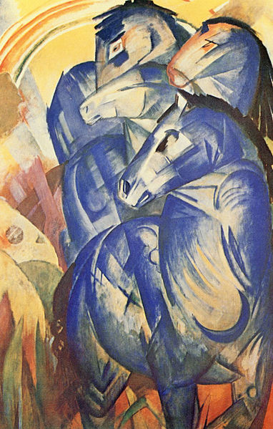

Franz Marc, *Der Turm der blauen Pferde* (The Tower of Blue Horses), 1913. German, 1880-1916. Oil on canvas. 200 x 130cm. Lost. Source and permissions: <http://en.wikipedia.org/wiki/File:Franz_Marc_029a.jpg>